Database Management System – cs422 DE
Lab 6 – Week 13
-----------------------------------------------------------------------------------------------------------------
This Lab is based on Query Processing.
- Submit your own work on time. No credit will be given if the lab is submitted after the due date.
- Note that the completed lab should be submitted in .doc, .docx, .rtf, .pdf or .zip format only.
---------------------------------------------------------------------------------------------------------------

Solve the following Exercises from the course text book.

- 23.17/21.17 (5th/4th edition)
Using the Hotel schema given at the start of the Exercise at the end of Chapter 3, determine whether the following queries are semantically correct
- SELECT r.type, r.price
FROM Room r, Hotel h
WHERE r.hotel_number=h.hotel_number AND
h.hotel_name=’Grosvenor Hotel AND’
r.type>100;

Not semantically correct: hotel_number and hotel_name are not the names of attributes in the schema; type is character string and so cannot be compared with an integer value (100).

- SELECT g.guestNo, g.name
FROM Hotel h, Booking b, Guest g
WHERE h, hotelNo=b.hotelNo AND h.hName=’Grosvenor Hotel’;

Not semantically correct: g.name and h.hName not in schema; Guest table not connected to remainder of query.

- SELECT r.roomNo, h.hotelNo
FROM Hotel h, Booking b, Room r
WHERE h.hotelNo=b.hotelNo AND h.hotelNo=’H21’ AND
b.roomNo=r.roomNo AND type=’s’ AND b.hotelNo=’H22’;

Not semantically correct: hotelNo cannot be both H@! and H22 in Booking.

- 23.18/21.18 (5th/4th edition)
- SELECT r.roomNo, r.type, r.price
FROM Room r, Booking b, Hotel h
WHERE r.roomNo=b.roomNo AND b.hotelNo=h.hotelNo AND
h.hotelName=’Grosvenor Hotel’ AND r.price>100;

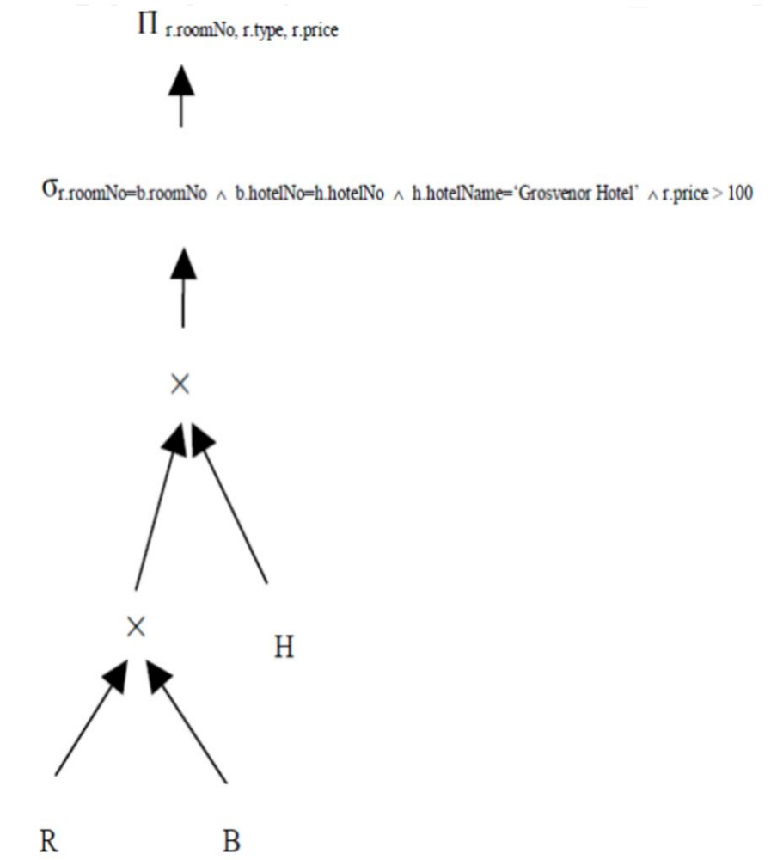

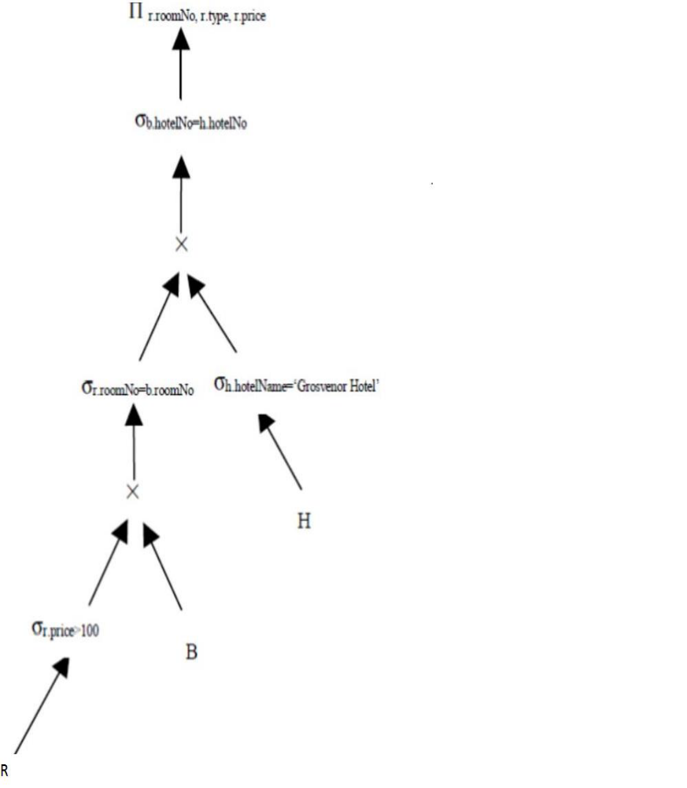

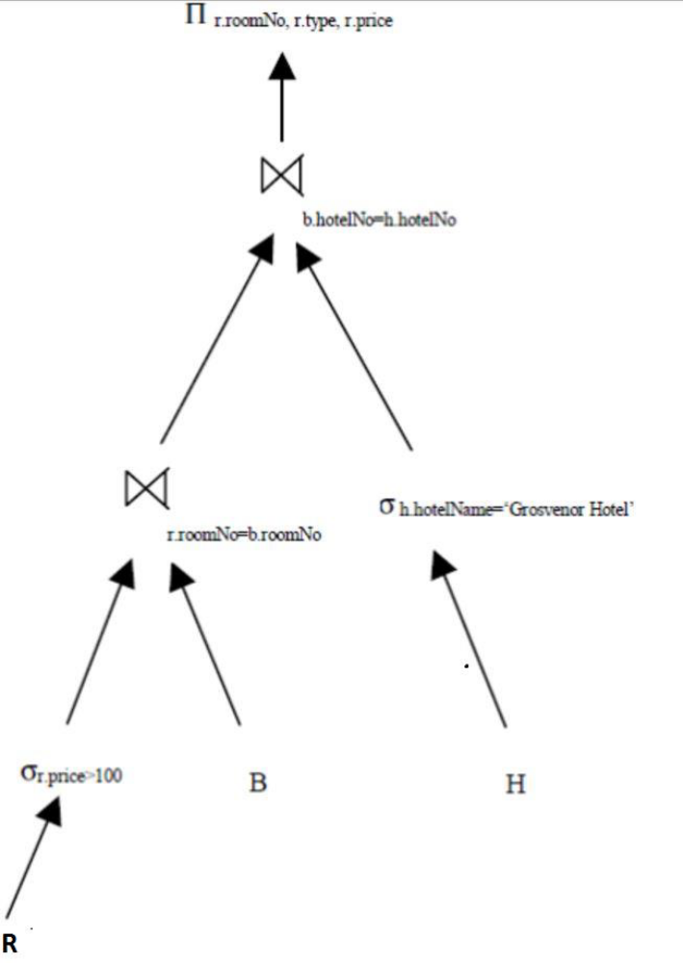

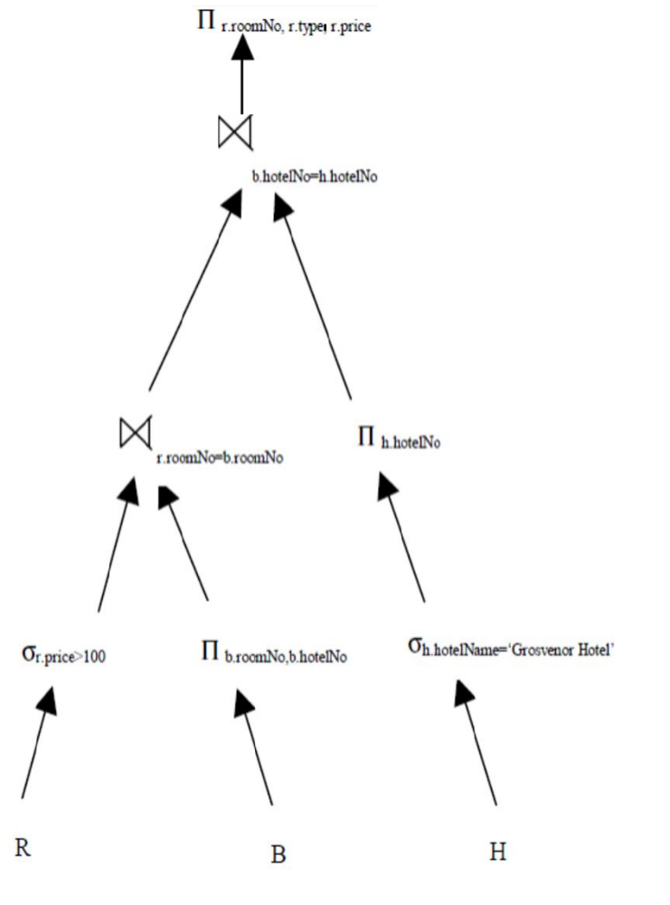

(b)SELECT g.guestNo, g.guestName
FROM Room r, Hotel h, Booking b, Guest g
WHERE h.hotelNo = b.hotelNo AND g.guestNo = b.guestNo AND
h.hotelNo = r.hotelNo AND h.hotelName = ‘Grosvenor Hotel’ AND
dateFrom >= ‘1-Jan-o4’ AND dateTo <= ’31-Dec-04’;

